Monica DeWald

Trip Review/Journal

Beijing Favorite Things:

1. **Dandelion School:** This was a very inspiring place! It reminded me of Seattle World School and I appreciated their vision and mission. It was interesting to see how much international support they had and I was surprised by how much funding they get from private donors. I think that my students could form some kind of pen pal relationship with them at some time during the next year.

2. **The Great Wall of China!**  This was way better than I had expected. It was really nice to see a more rural and natural part of China and enjoy panoramic views. It was not touristy feeling and the lunch was very good too. :) The drive also gave us some perspective about how big Beijing really is. (Are we still in Beijing?)

3. **The hutongs**. I loved the rickshaw ride, hutong lunch and staying in a hutong area. It was really cool to see that traditional part of Beijing, and also to view the changes that have been made in that area (upscale shops and bubble tea places, new hutong developments (from Dana, Jeromie and my walk), and hutong restorations) It showed me how the people of Beijing are adapting those buildings and style to suit their current needs.

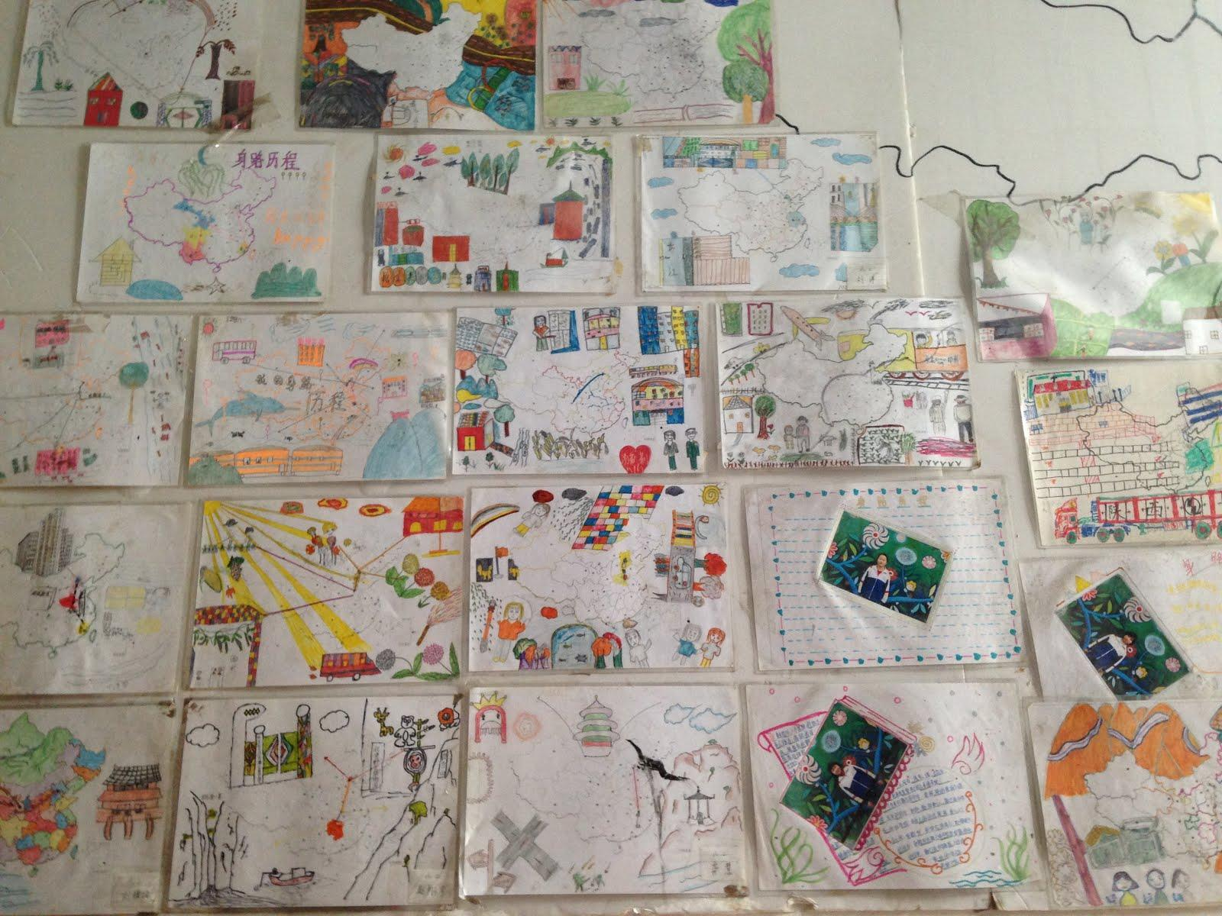

a project from the Dandelion school, encouraging students to “own” their migration journey.

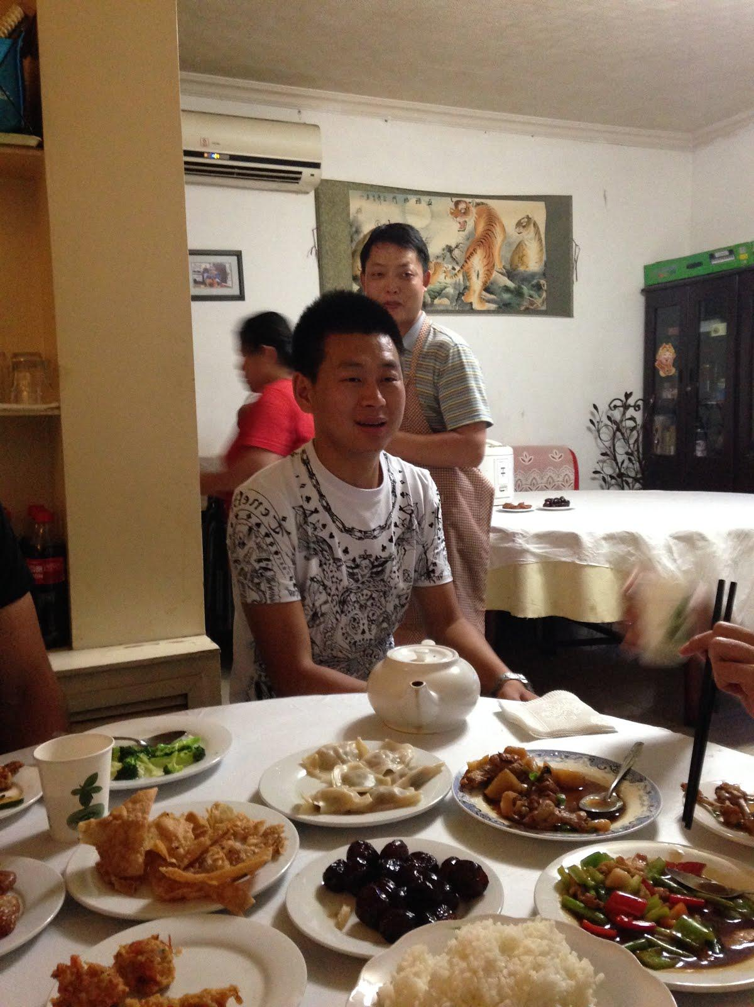

hutong lunch

Ju’er hutong in the morning

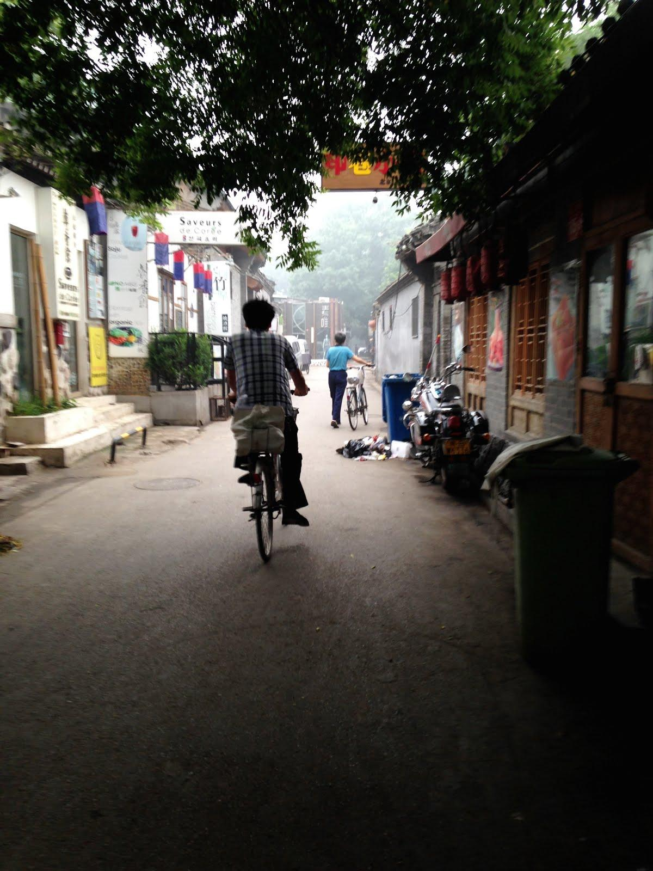

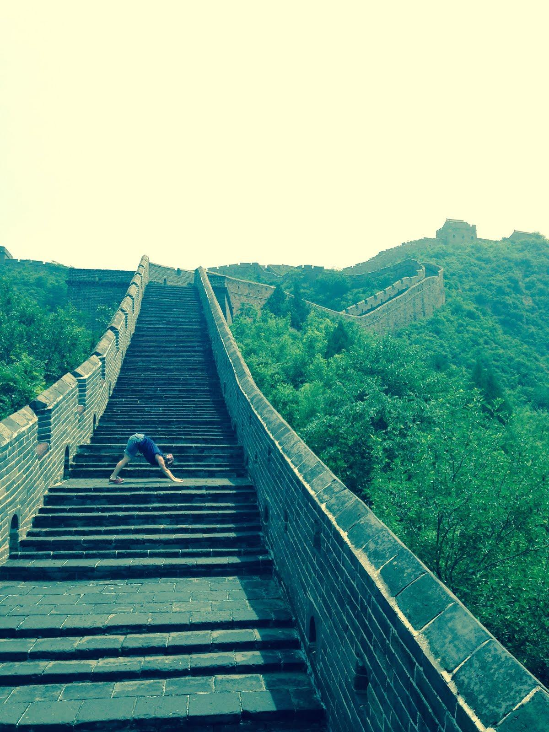less popular yoga poses on the great wall

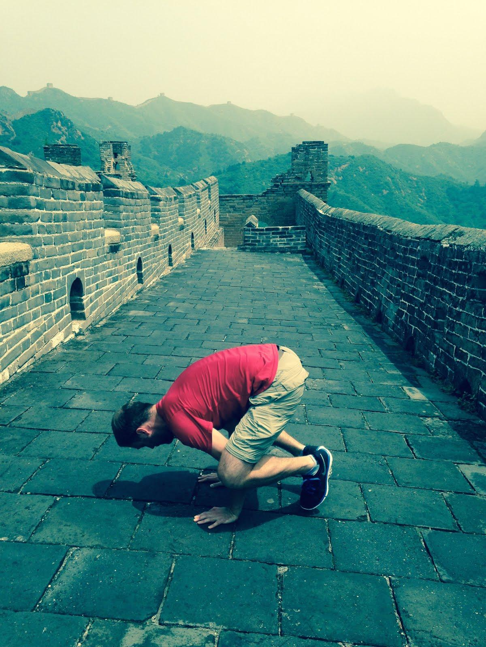

less popular yoga poses on the great wall

Xi’an Favorite Things:

1. **The train to Xi’an.**  The train was actually one of my favorite parts. I enjoyed the experience of the train station in Beijing (wow so many people!) and also I loved being able to see the countryside and wake up and see the sunrise over the mountains and valleys. It also seemed like a good way to travel. We slept practically the whole time and arrived relaxed to our destination.

2. **Xi’an art museum**. I loved the calligraphy lesson and the guided tour through the artwork. It was really interesting and the guides made the experience so much better. Also, I loved the farmers’ paintings and bought 3…..

3. **The Muslim Market.** It was awesome to be so close to the Muslim market. I could imagine being there hundreds of years ago and having a similar sensory experience. I loved seeing all the different kinds of people and vendors and it was interesting to just let yourself be absorbed by the thousands of “stories” taking place all over those streets. Additionally, **the mosque** was a fascinating place to visit, as it’s completely different from any other mosque I’ve seen.

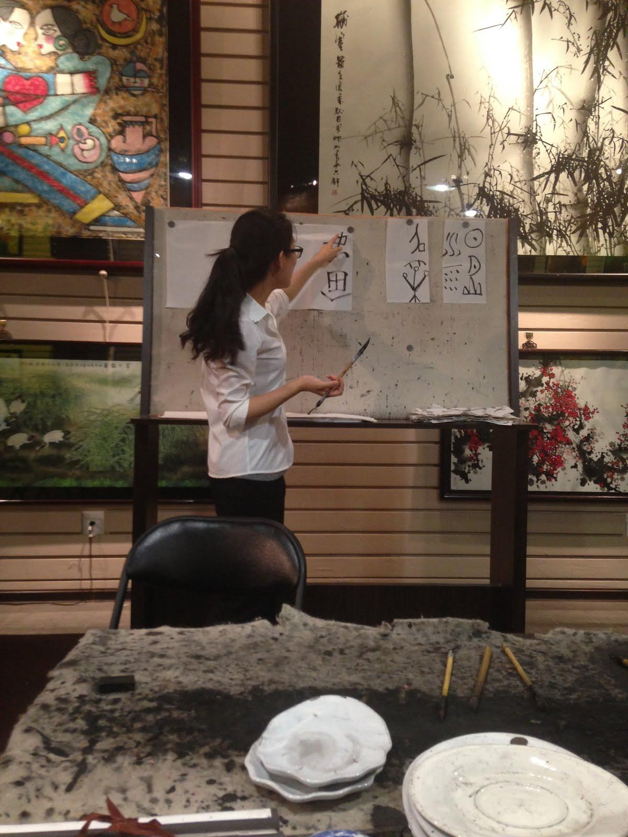

calligraphy lesson

hot beef pancake soup 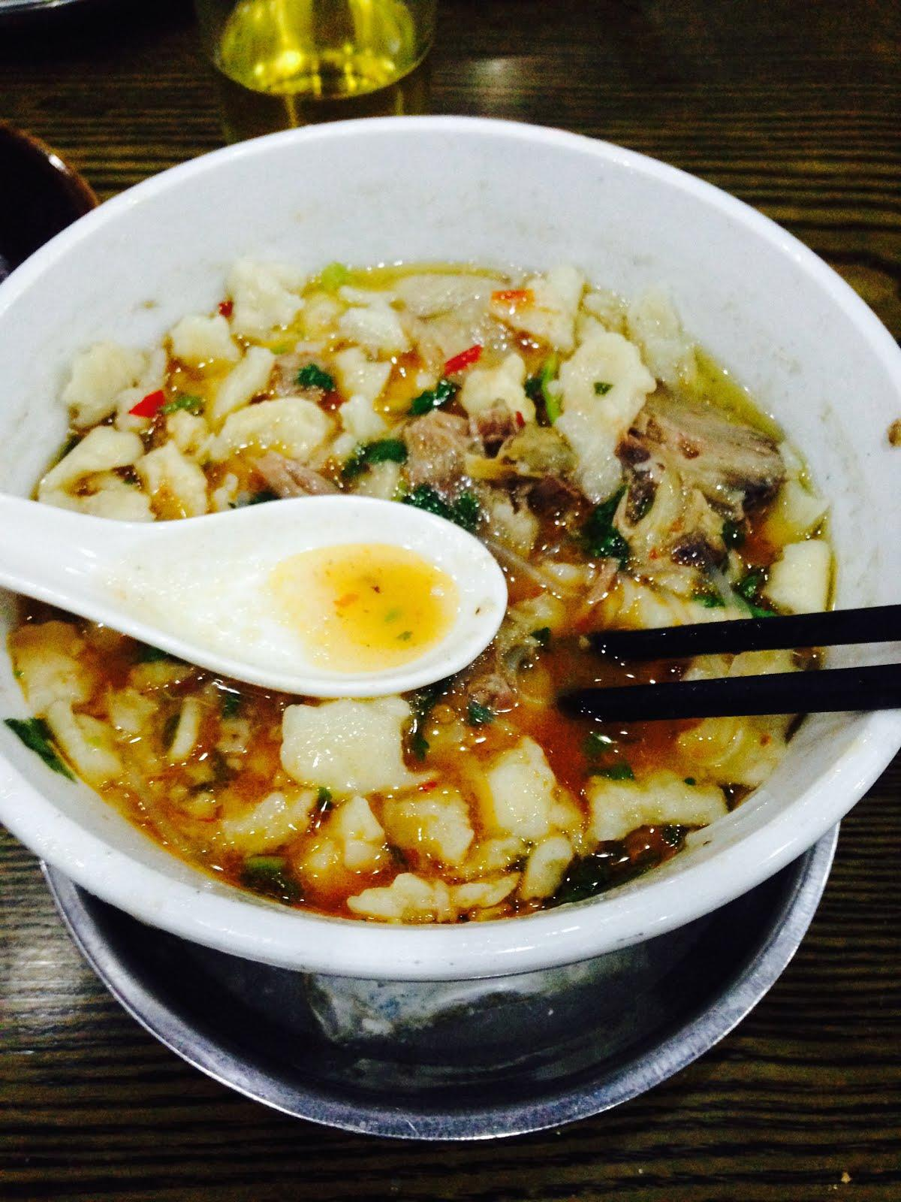

Muslim market. What an experience.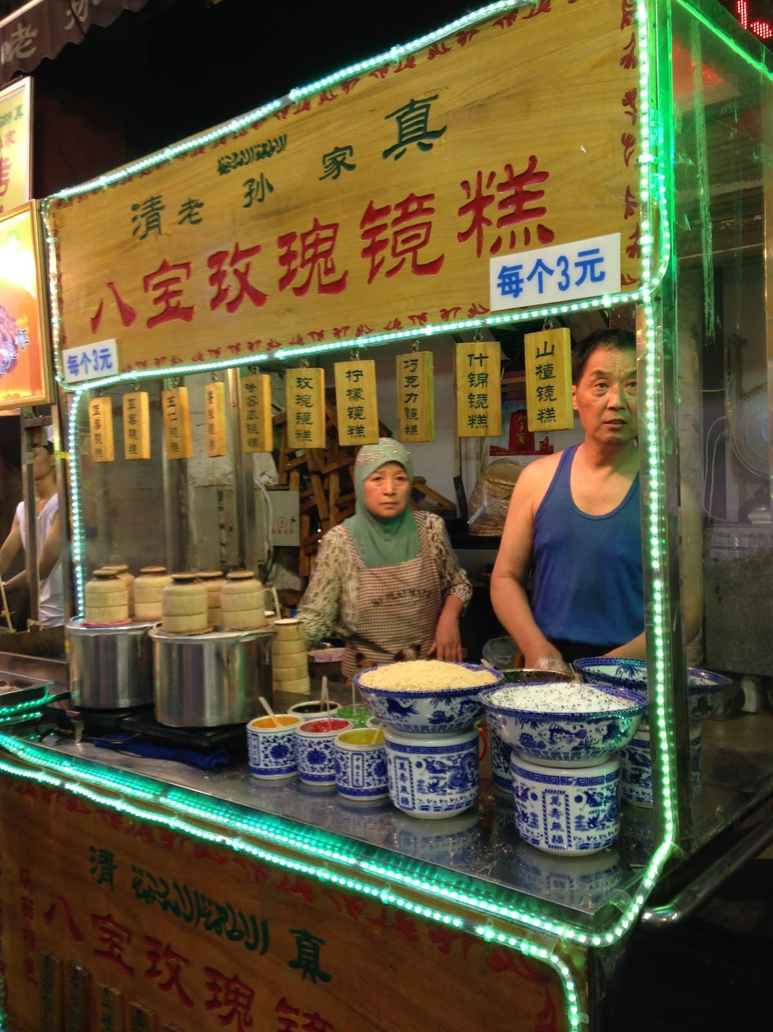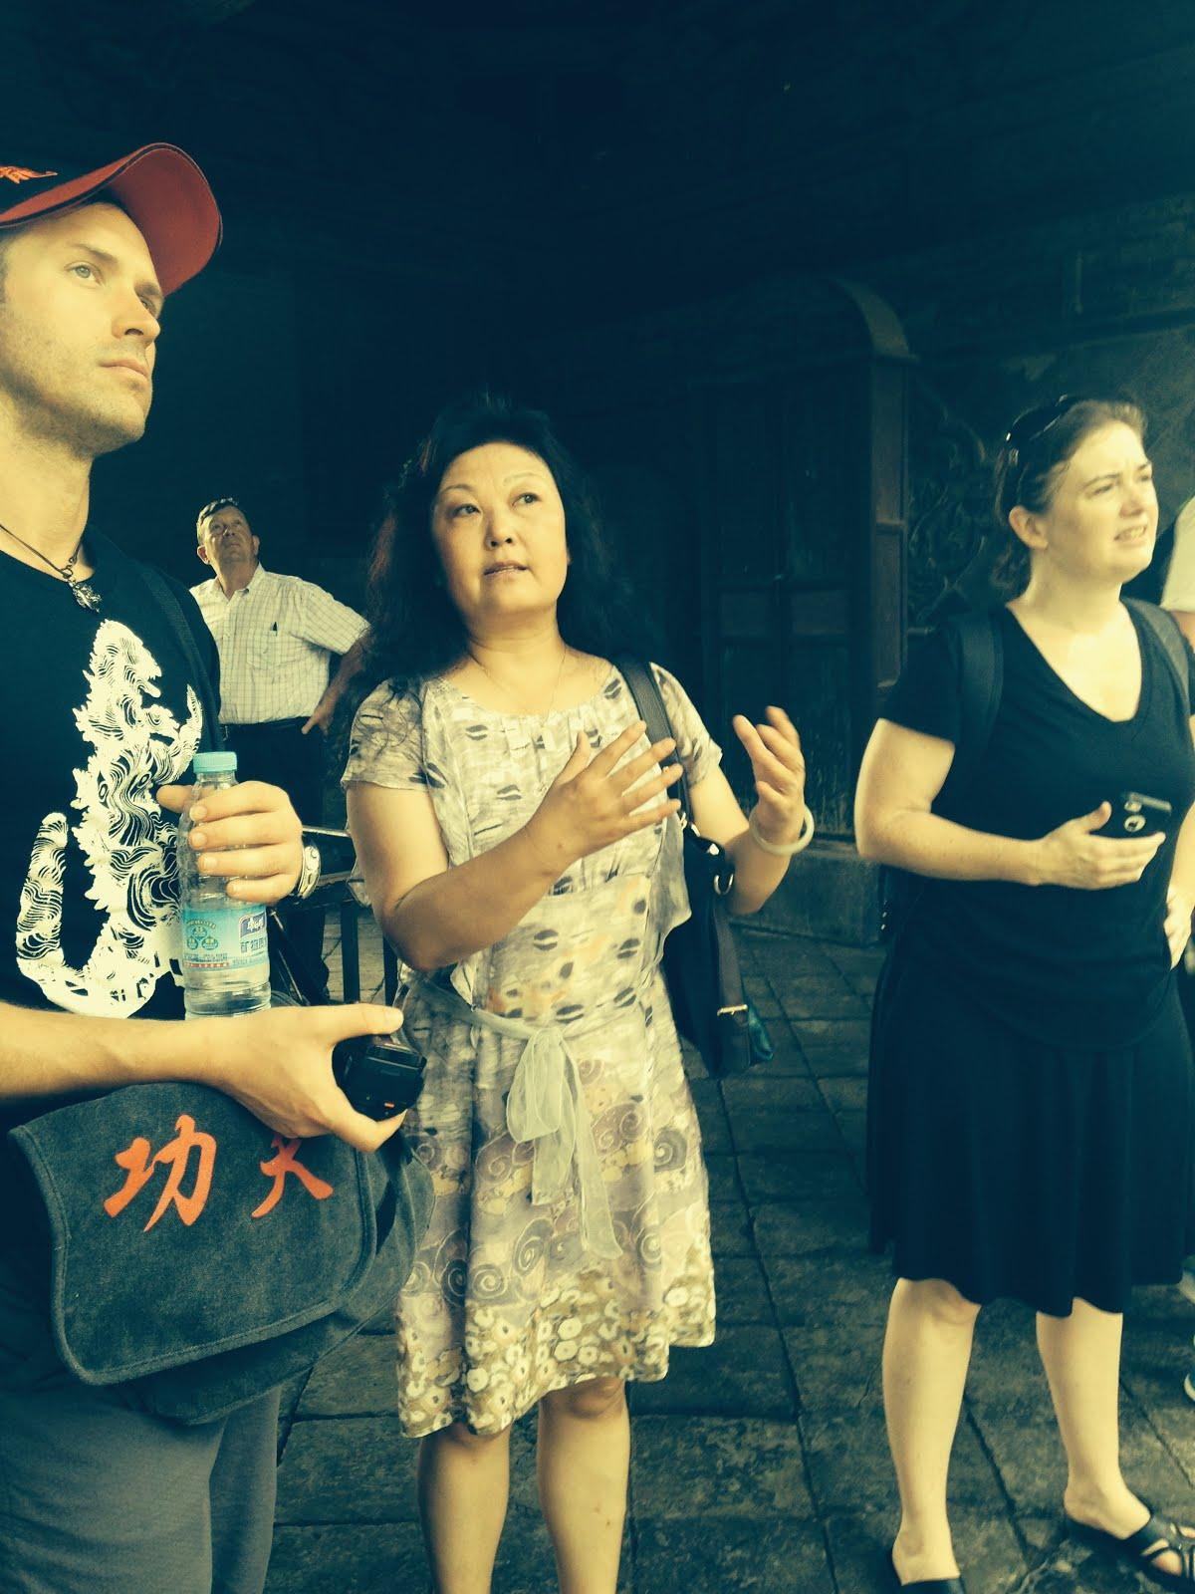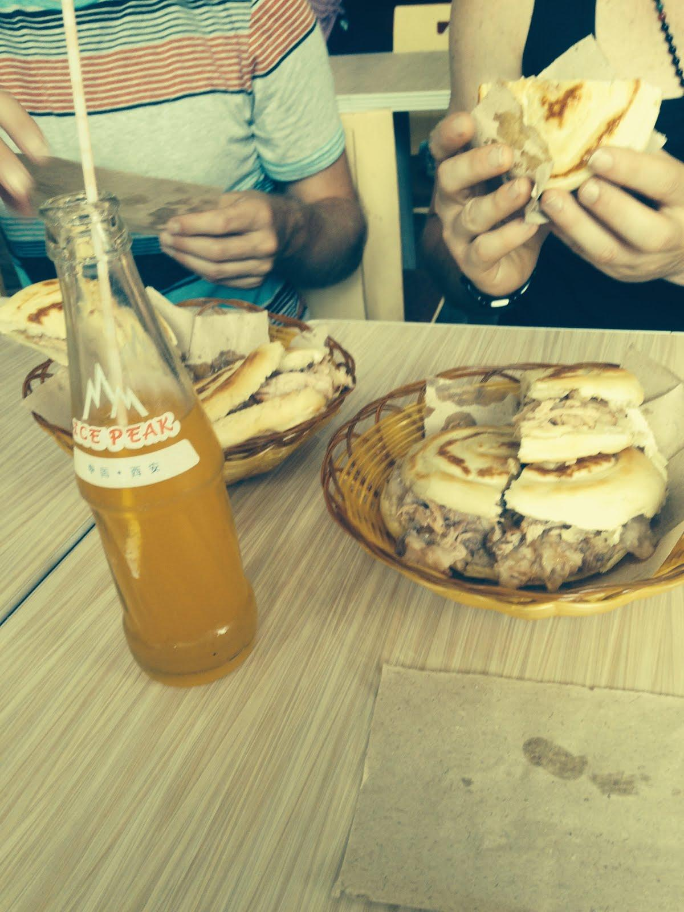

The greasiest meal I have ever eaten. So good at the time, not so good afterwards….

Shanghai Favorite Things:

1. **Dinner with Amy Zhang’s family**. I loved spending time with Amy’s family. It was so fun to meet the different generations and have a unique experience, making and eating food and learning about Shanghai through their eyes. It was also cool to see one of the skyscrapers in Shanghai. On the 23rd, floor, you really got perspective.

2. **Meetup with Elsie and the students.**  We got to meet with a bunch of students from a town near Shanghai. This event was such a surprise! The students were so adoring and wonderful to give us gifts and present their talents to us. I also feel like I was able to gain some interesting insights by talking to the university students who were there.

3. **The garden of Shanghai.** This place was really beautiful and a nice place to visit. I loved seeing all of the details that went into its creation and learning about its history. It also provided a few opportunities to learn about traditional and modern culture in Shanghai. 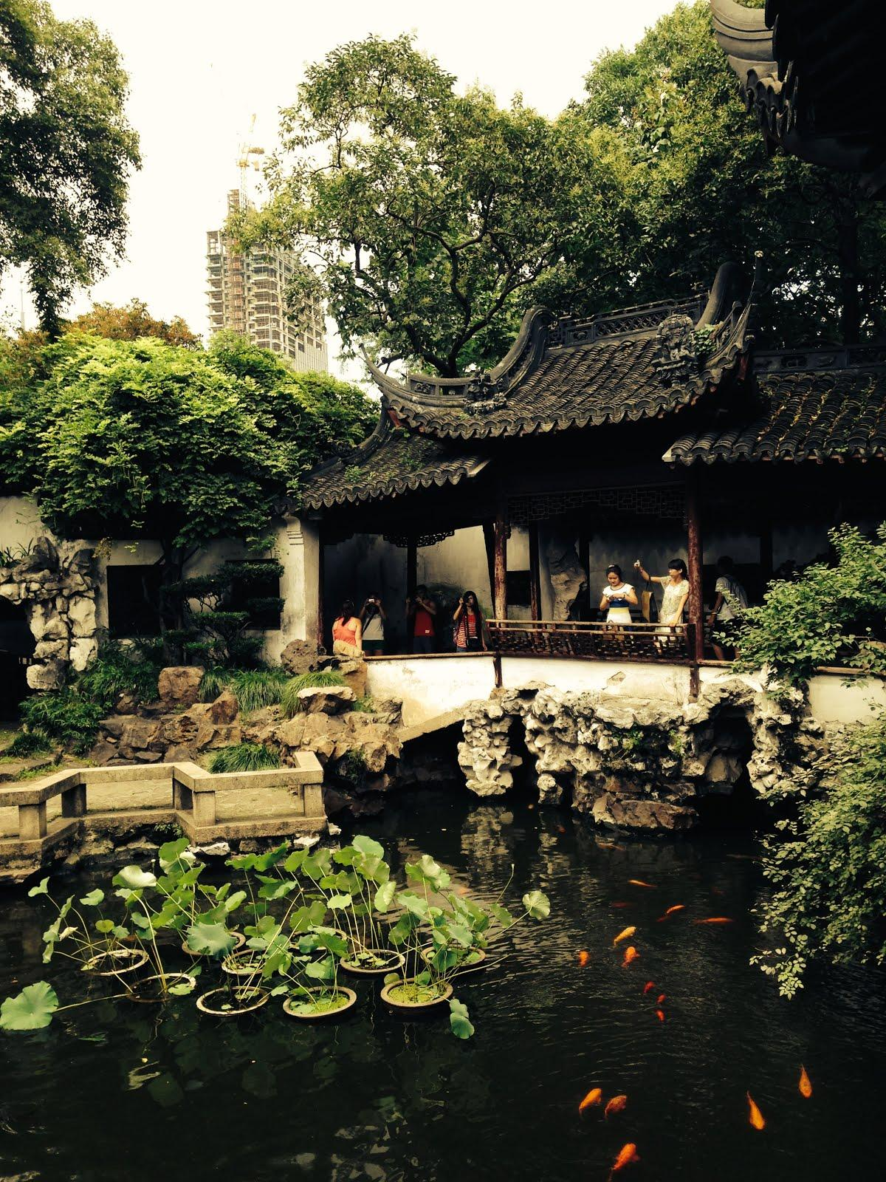

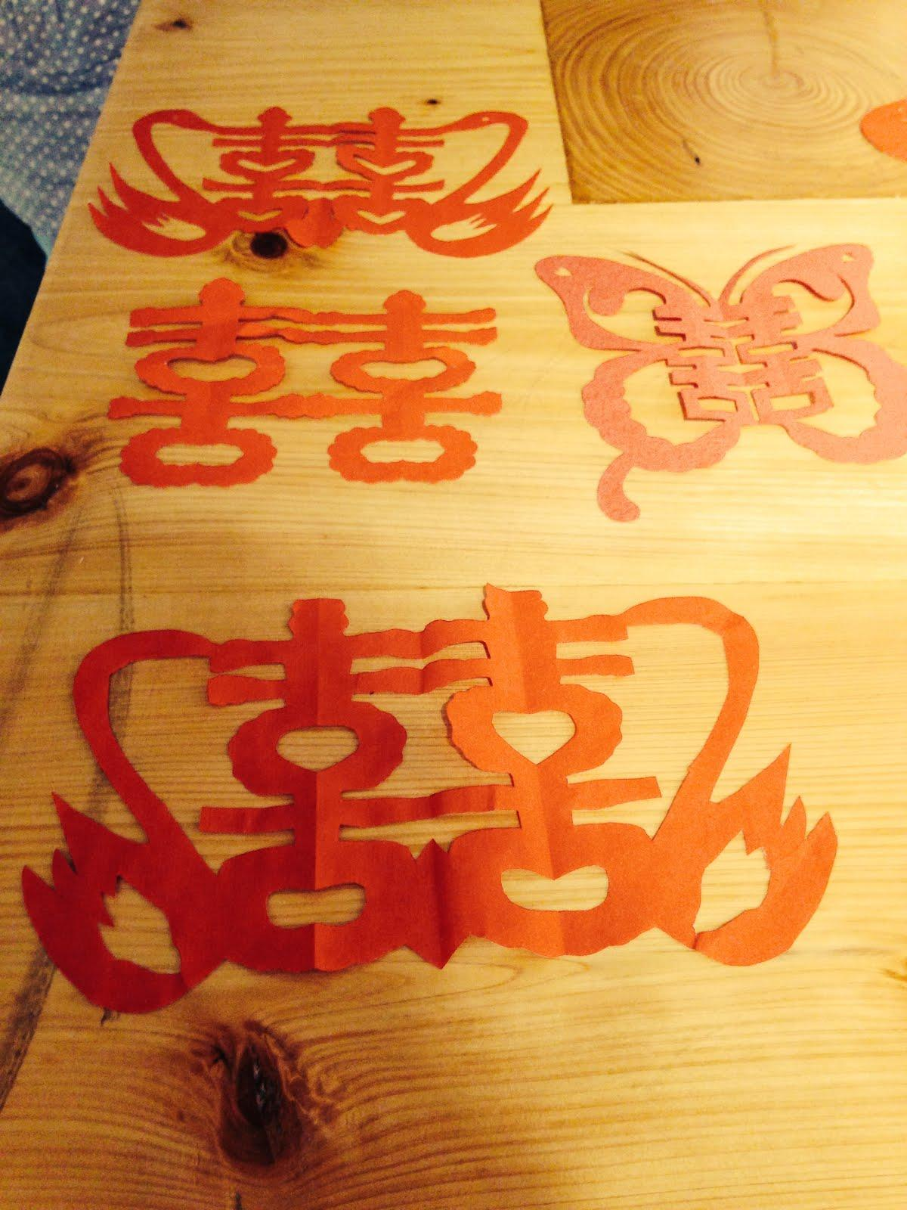

double happiness! Paper cut outs made by Elsie’s student group.

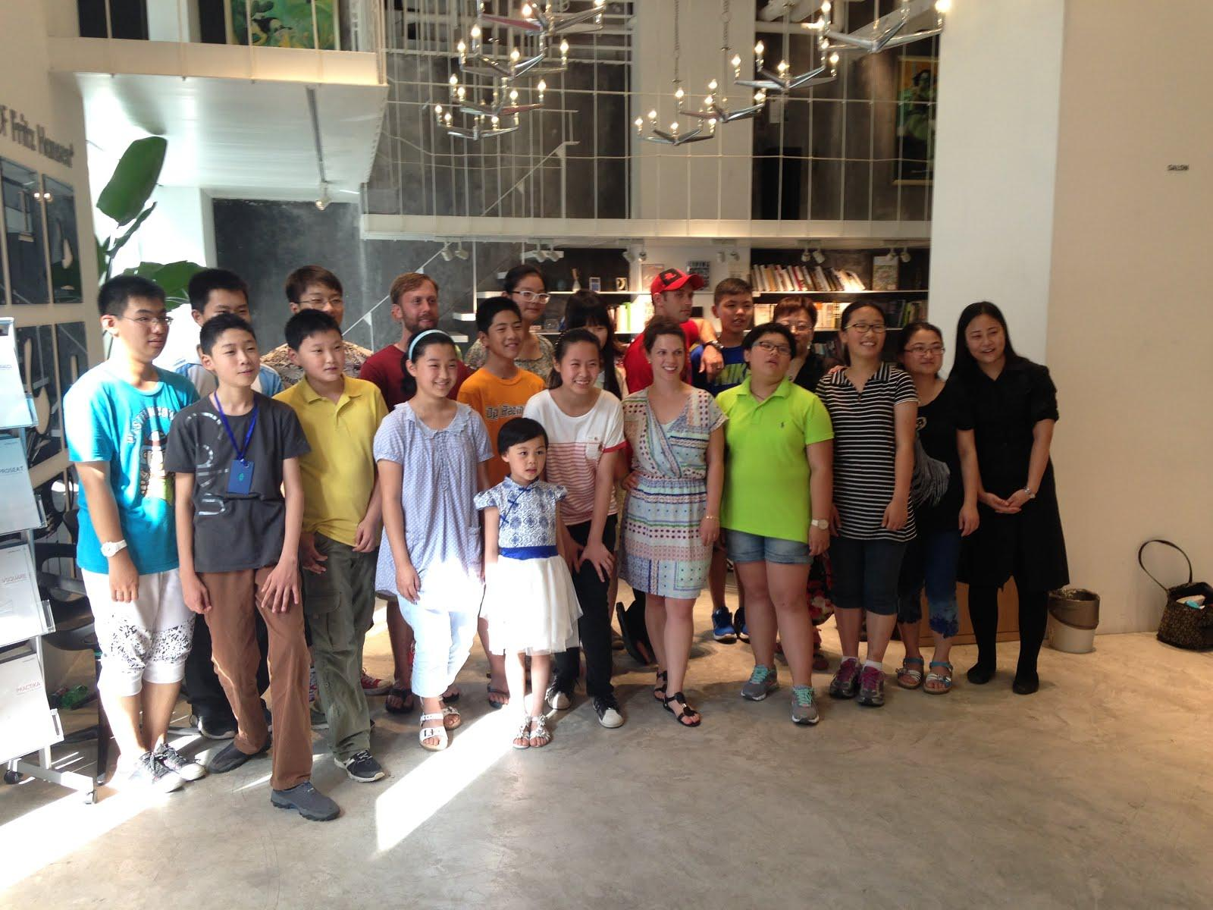

Elsie’s group

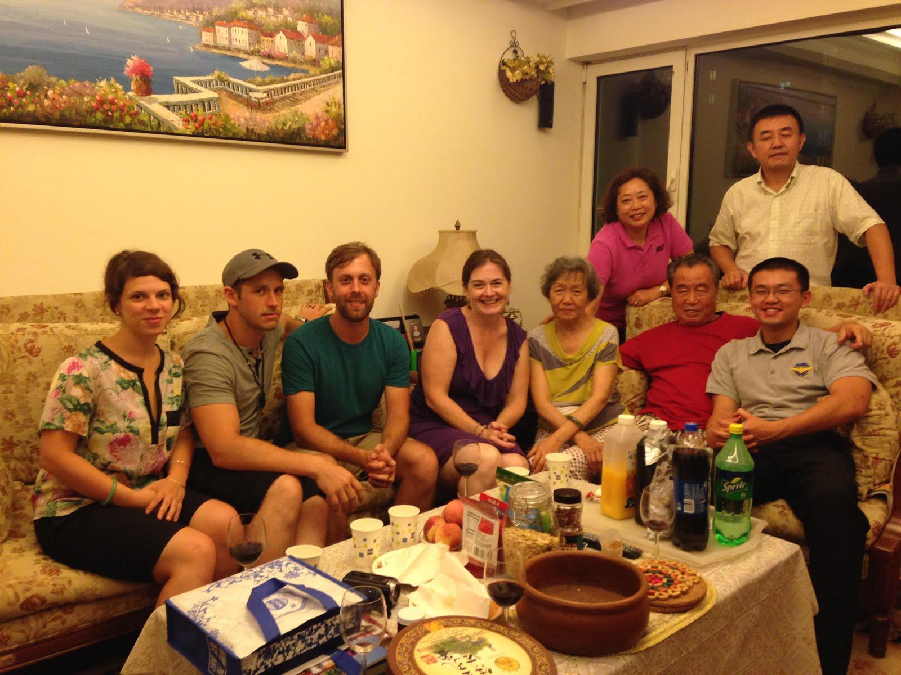

The Zhang family

Favorite Taiwan Things:

1. **The Modern Dance show!**  This was a really cool experience! I loved being able to see so many people enjoying this show. Cloudgate performed a beautiful show and it was such a wonderful cultural experience to be a part of a huge crowd of enthusiastic and polite fans!

2. **The tea farm.**  This was one of my favorite things of the whole trip. Seeing the process of tea, from leaves to product, as well as a family who has been operating a small farm for many generations, was such a cool experience. I also LOVE drinking tea, so the tasting portion was great as well. The mountain was so peaceful and green, (and hot) I could see why the farmers enjoy their work so much.

3. **The vocational high school.**  This was an inspiring place! The program is so comprehensive that it reminded me of a community college. The student work was incredible and I appreciated their realistic and progressive view of education. I feel like our high schools and educational model could learn a lot from Taiwan’s vocational schools and it would be better for everyone. I’m hoping that we can continue communication with that school and its students in the future, as they had mentioned that they would love a sister school and some opportunities for exchange programs.

4. **Spending time with friends and family.** My actual favorite part of every city was spending time with the people there. Taiwan allowed us to have more friends than any other city :) We loved being with Suya, Pia, Megan and her family, Susan and HH and Ruby! It was great to have a casual time talking and having fun with new friends. Those are the memories that I will remember long after this trip. Hopefully we will be able to return the favor and host our friends here in Seattle.

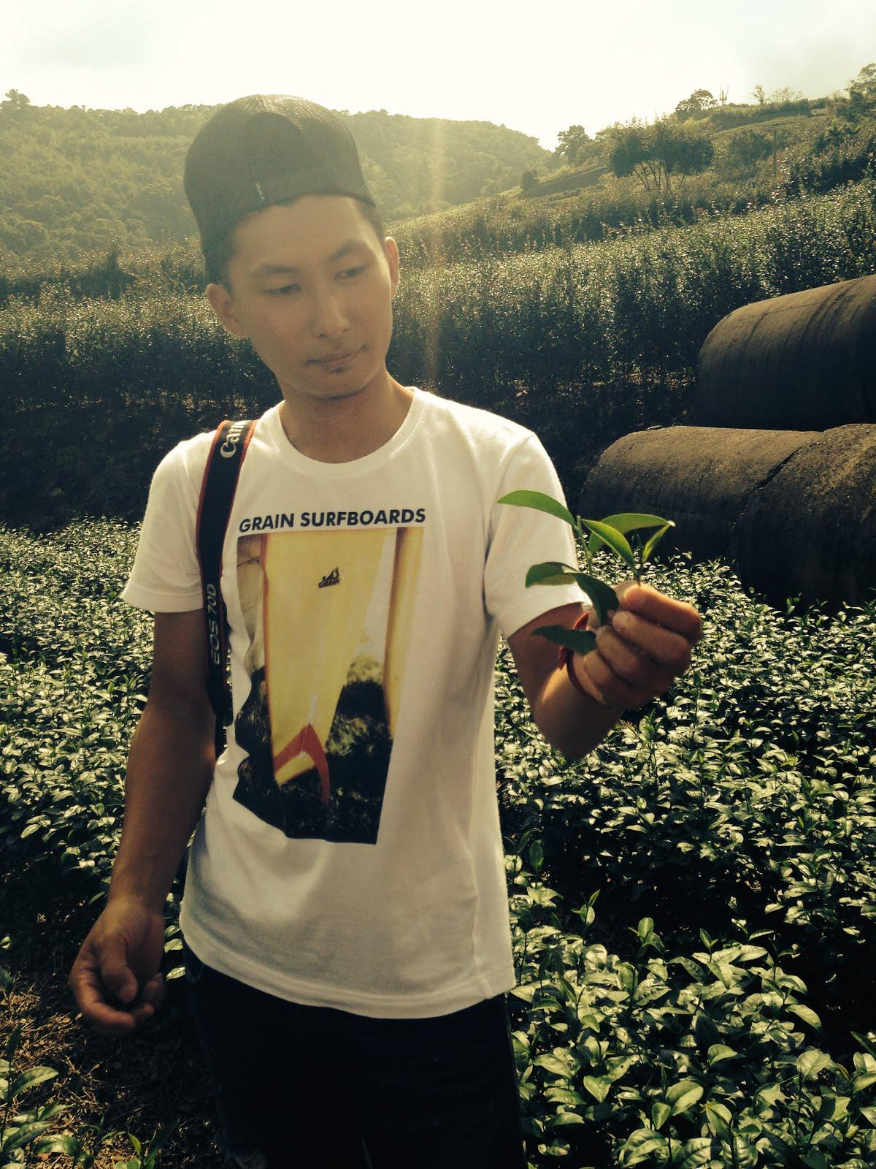

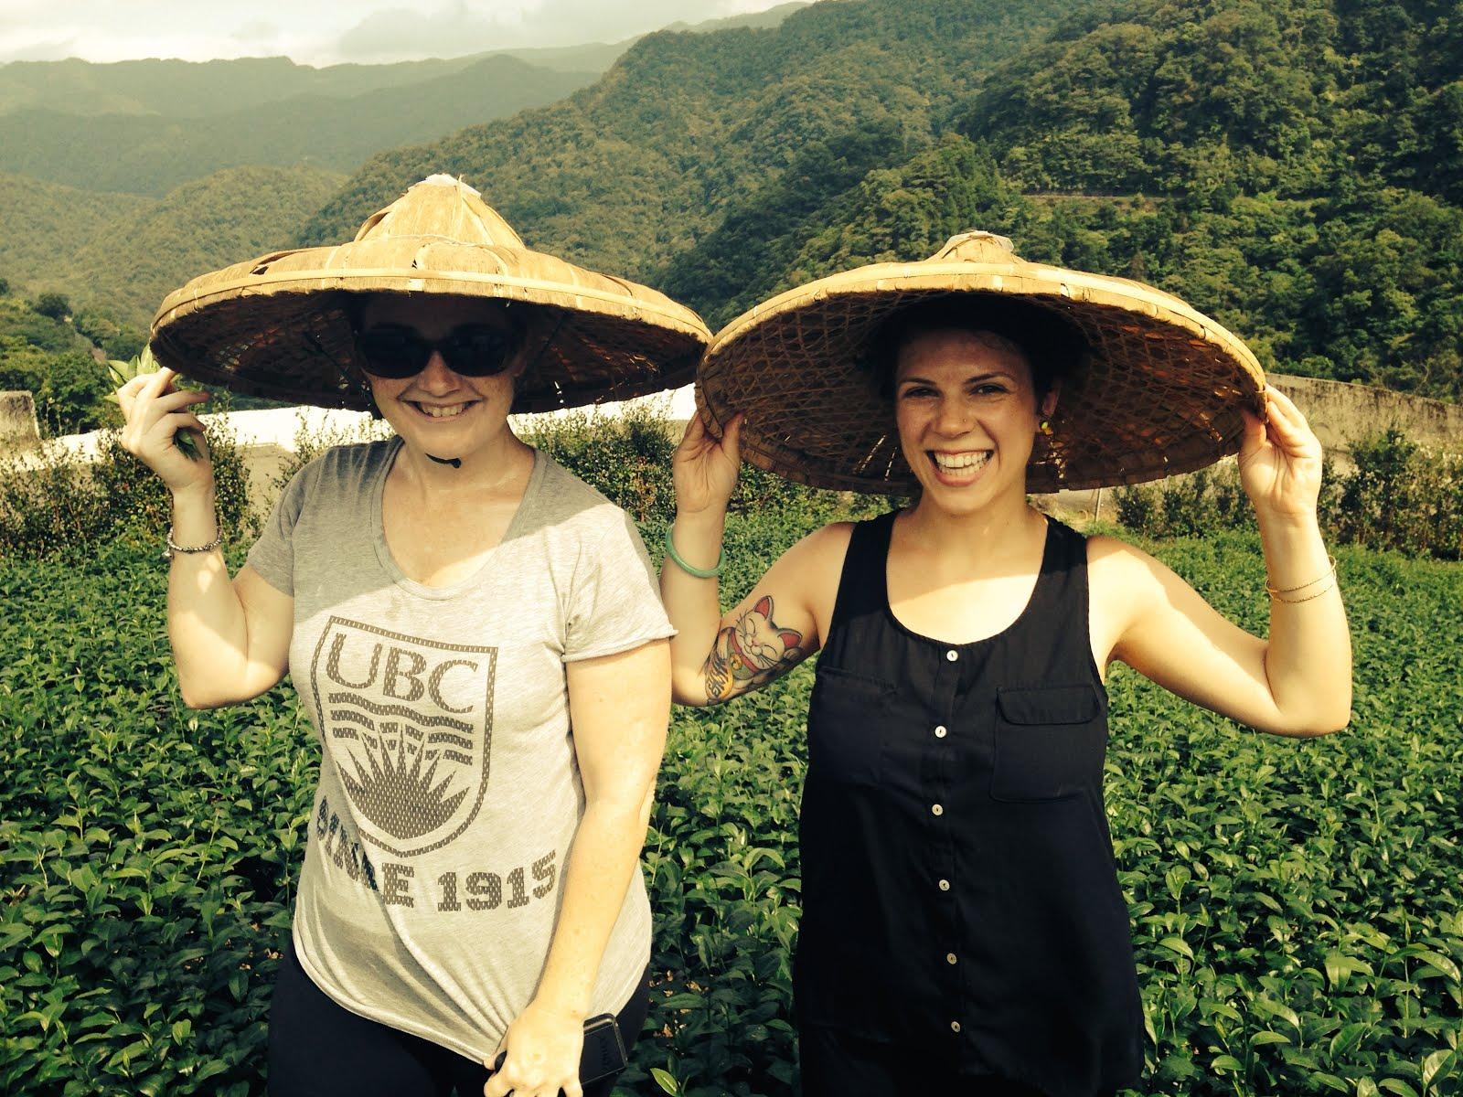

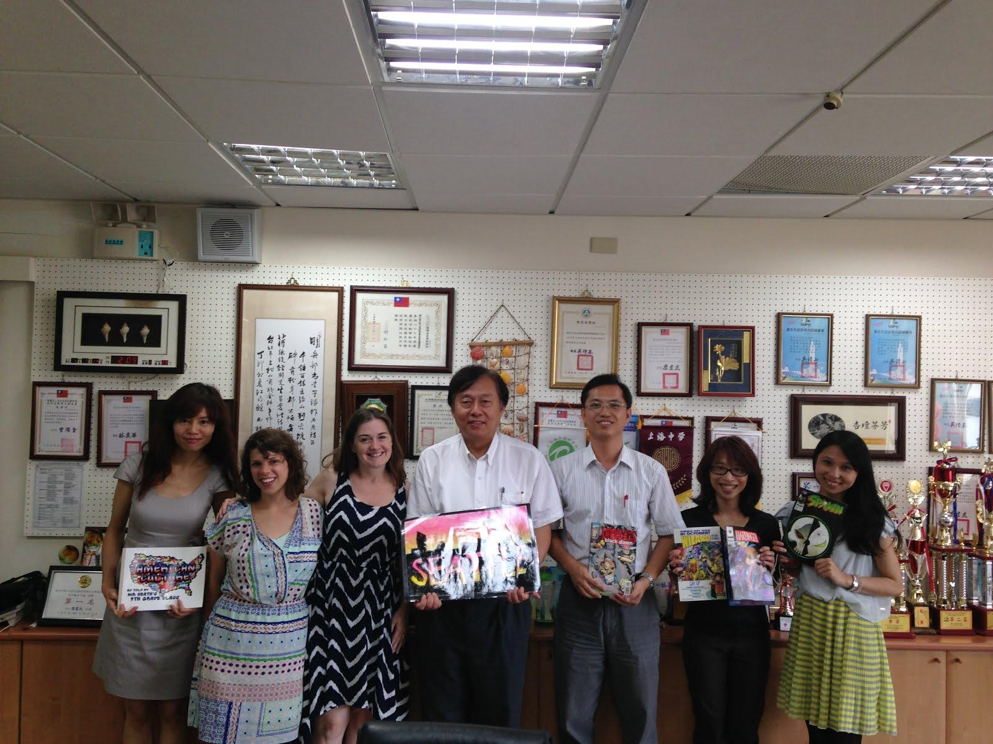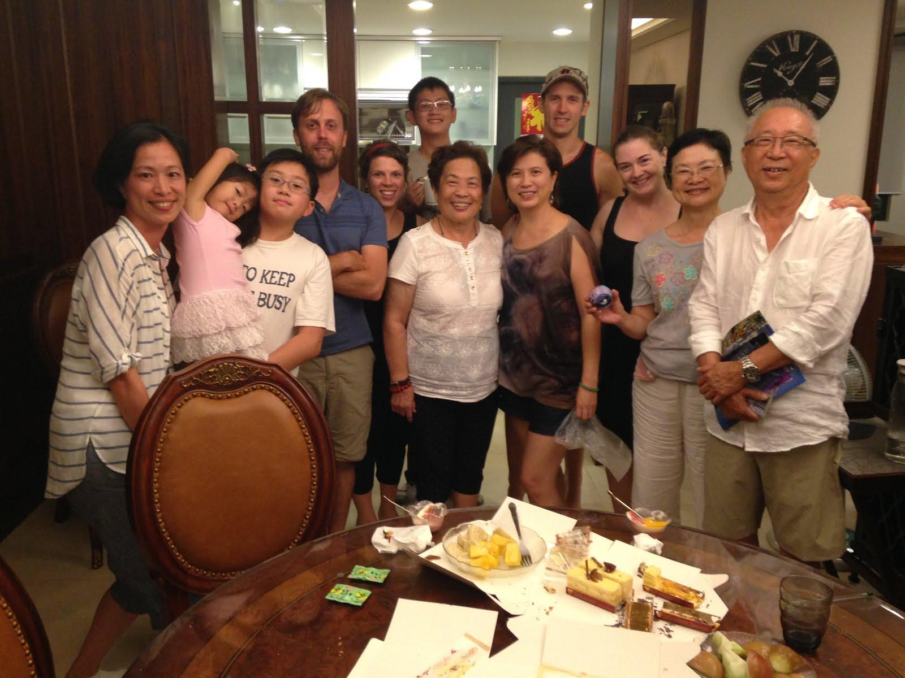

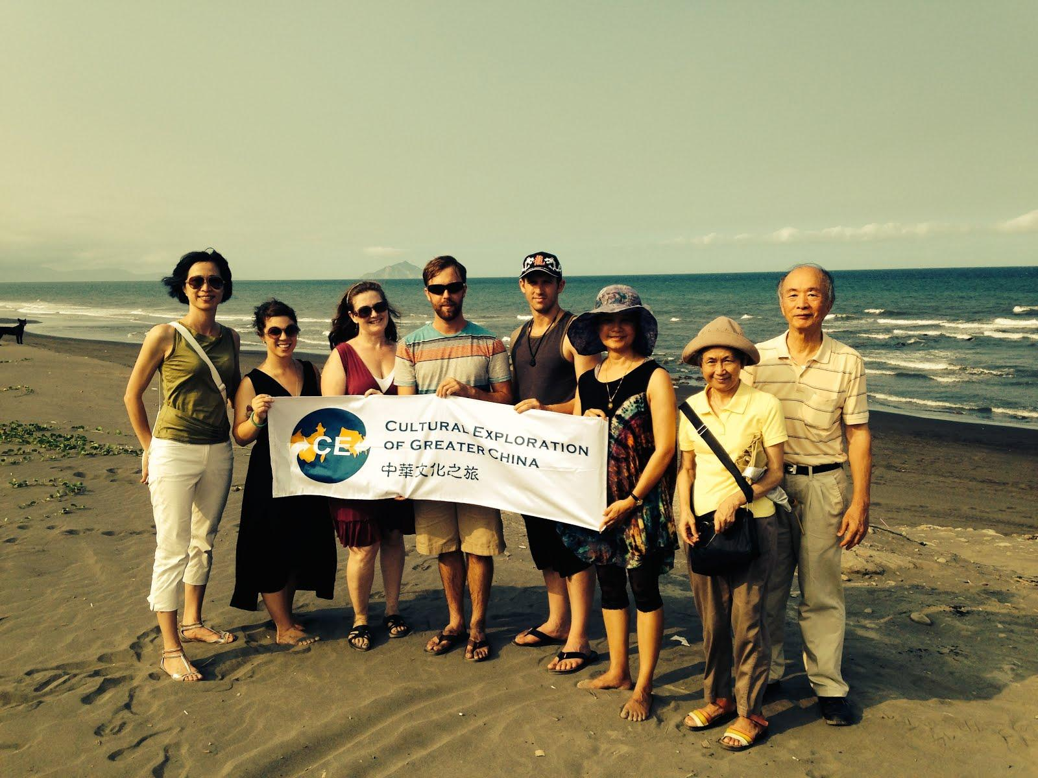

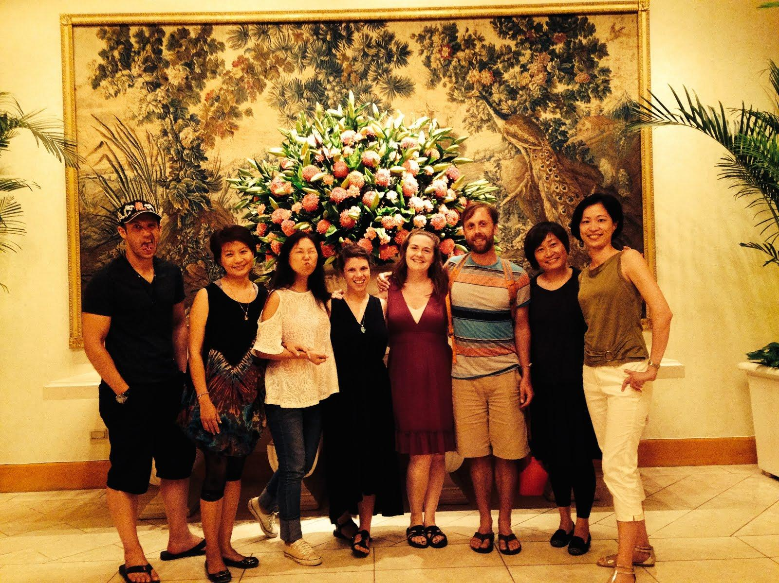

**This trip provided me a lot of “Aha” moments.**

The most interesting things to me were the realization that in the Chinese language, every character has a meaning, or multiple meanings, both visually and symbolically. For that reason, it should be no surprise that my Chinese students spend so much time using translators to translate every single word in a text. English words just don’t carry the same weight as Chinese characters, and I think knowing that will help me to explain reading skills to my Chinese students without getting mad at them for always having translators out and not listening to me!

One of the questions that I had before going on this trip was about how Chinese and Taiwanese people see and value their culture. In every city, I was able to see that the people there definitely cherished their heritage and had an intense pride of their history and traditions. The most profound story to me, was the story of the Forbidden Palace treasures. I had no idea about how quickly they were put in boxes and moved out to protect them from the Japanese invasion, or that they had to move them around from city to city and onto trucks and then onto boats and none of the boxes were ever lost. What a wonderful example of a culture that really wants to protect their treasures! I love that story and I was able to see evidence of that spirit in all the places that we went.

After visiting the American School in Shanghai, I realized that I actually had no idea what a “real” Chinese school is like. When they say “East meets West” what do they mean? What is “East”? I have heard a lot of negative talk about memorization and large class sizes and a de emphasis on creative and critical thinking, but I never had a chance to see that for myself. We saw a lot of exceptional schools, and those students were truly incredible, but it made me wonder what “regular” kids are like in China. I have a hard time believing that it could be that bad. The students that came with Elsie came from a “regular” school I think? And they were some of the most creative and talented students that we saw, each of them well-versed in traditional arts.